Preliminary Investigation into Fire Service Survey Responses

David Marx

2/3/2017

## Executive Summary

The Fire Service Survey is an annual survey administered by the NFPA. One of the main functions of the survey is to perform a needs assessment of departments in the US fire service. A preliminary investigation of a sample of survey responses identified that:

* 18% of departments experienced a decling in paid/FTE firefighters since 2011
* Over 54% of departments are running apparatus that is 15+ years old
* 21% of volunteer departments had at least 14% female staff, whereas only 1% of paid departments did.

## The Survey

Survey results were provided for analytics with very little context. A data dictionary was provided in the form of an annotated version of the survey, where the questions asked by departments were matched to the corresponding column names in the data.

Part II, Question 5 asks:

"Has your department had a reduction or increase in total firefighter positions of full time equivalents (FTE) since 2011?"

so it can therefore be presumed that the year of the data was from 2012 or later.

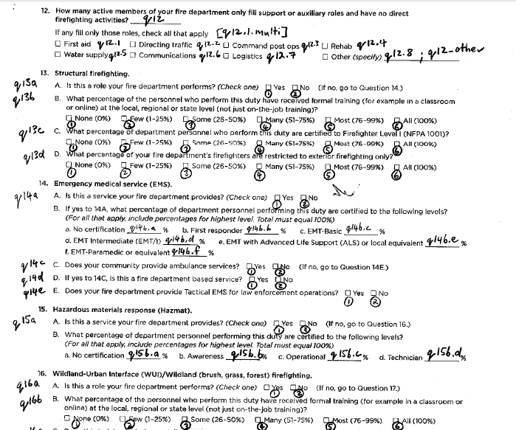

Data Dictionary

Departments from all across the country were represented, with 5458 departments responding in total.

## Suggestions for Improvement to survey

### Survey Administration

The provided sample survey (the data dictionary) illustrates that the survey is being completed by hand and then results are collected by human data entry. This process is time consuming for all involved, error-prone, and unnecessarily expensive. Associated costs include: printing the survey, mailing the survey, delivering responses, human data entry of responses. All of these costs are relieved by administering future surveys using a digital platform. Because the contents of this survey are not sensitive, future surveys could be administered using free platforms such as Google Forms or SurveyMonkey. Migrating to a digital platform would also increase the quality of the data collected in the survey by removing the possibility of errors introduced as a consequence of human data entry, and adding data validation and integrity checks as part of the survey completion process.

### Survey Questions

The survey prompts for responses on certain questions in a way that unnecessarily reduces data granularity. Many questions on the survey ask for the respondent to provide a value, but then invite the respondent to communicate the value as a range. Consider question 16:

"What percentage of personnel who perform this duty have received formal training?" A. None (0%) B. Few (1-25%) C. Some (26-50%) D. Many (51-75%) E. Most (76-99%) F. All (100%)

Contrast this with question 14b, which requires the respondent to provide (or at least aproximate) specific values of percentages for each EMS training level in their department.

Respondents should be asked to provide (or approximate) precise values where ever possible.

### Issues with Data Representation

Null data was represented in multiple ways, primarily as either empty cells (199,102 occurrences), the text value '#NULL!' (188,236 occurrences) or white space (56,520 occurrences. In many instances, null data was not intended communicate a null response, but likely a zero-value response (e.g. in fields prompting for counts). Migrating to digital survey administration would eliminate this ambiguity and enforce a consistent representation for null data and ensure zero values are represented explicitly.

Numeric values were often represented as comma-delimited numbers, i.e. text of the form "xx,xxx". Representing numbers as texts adds an unnecessary preprocessing step when working with the data and can cause analytical mistakes. This is another problem that would be completely rectified by using a digital form to administer the survey.

Finally, several columns in the data were out of order relative to their ordering in the survey. This makes it appear, at first glance, as though a quarter of the variables are missing and introduces unnecessary risk of error if an analyst attempts to use numeric indexing to get to the variables they want rather than accessing them by name.

## FINDINGS

## Stability of staffing levels

52% of departments have no full-time paid personnel. Of those that have paid personnel, relative to 2011 (and excluding departments that reported zero paid personnel in 2011):

* 18% experienced a staffing decline
* 25% experienced a staffing increase
* 57% experienced no net change to staffing

The following chart provides the empirical cumulative distribution function for the net percent change for all departments relative to their 2011 paid staffing levels.

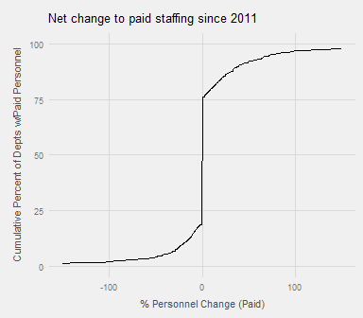

## Representation of Women

Controlling for department size, women have measurably higher representation in volunteer departments. This was determined by treating reported counts of part-time/volunteer vs. paid/FTE as separate "departments" (so for this analysis, "volunteer department" is used to mean "volunteer *side*" for departments that employ both paid and volunteer firefighters), then fitting a logistic regression to the department type against the predictors of total firefighter count and female firefighter count for the department. Concretely, using the model formula:

$$isVolunteerDept∼totalFF+femaleFF$$

gave the resulting model:

|  |  |  |  |  |
| --- | --- | --- | --- | --- |
|  | Estimate | Std. Error | z value | Pr(>|z|) |
| (Intercept) | 1.6414057 | 0.0612496 | 26.79865 | <2e-16 |
| female_ff | 0.2008580 | 0.0126106 | 15.92773 | <2e-16 |
| total_ff | -0.0289682 | 0.0013922 | -20.80738 | <2e-16 |

Because volunteer departments are generally small, we should expect the size of the department to have a strong effect on our ability to predict, in the absence of other information, if that department is paid or volunteer. From the coefficients of this model, we can see that adding a single female firefighter to a department increases the odds of that department being volunteer approximately seven times more than if we remove a random firefighter.

The above model provides us with a decision boundary given by the line

$$femaleFF=0.144totalFF-8.17$$

In other words, if we observe that a department has over about 14% female firefighters, it's extremely likely (77% accuracy) that department is volunteer. We can see this phenomenon graphically:

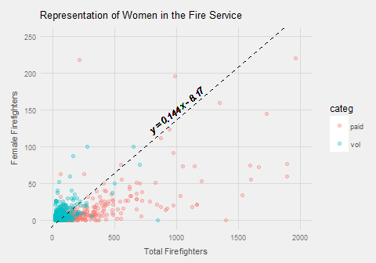

Concretely, 21% of volunteer departments had at least 14% female staff, whereas only 1% of paid departments did.

### Model Validation

To confirm this analysis, the accuracy statistic was investigated via permutation testing. To ensure the model was not "overfit" to the data, performance on out-of-sample data was evaluated using the bootstrap technique. A value of 77.0% was found for the bootstrapped accuracy with 2000 replications, with a 95% confidence interval of 75.3% - 78.7%. This confirms that the model was not fitting noist

To ensure that the model performs better than random (i.e. that the accuracy was not a consequence of class imbalance), significance testing was accomplished by performing a permutation test (aka "target shuffling") with 200 replications over the bootstrapped accuracy statistic (with 200 replications, which was found to be sufficient to match the results of the 2000 replications bootstrapped accuracy), producing an estimated p-value of p < .005.

Finally, the overall model performance was evaluated using a Reciever Operator Characteristic (ROC) curve. The curve illustrated that high probability assignments capture most of the positive class in the data (i.e. the model assigns high probability appropriately). Additionally, the area under the ROC curve (AUC) was found to be $0.84$, providing additionally evidence that the model performs well (AUC close to 1 is good).

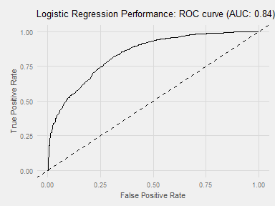

## Aging Fleet

Many departments have units in service that are at least 15 years old. Percentage of departments with at least one in-service suppresion unit of the following types, that is at least 15 years old:

|  |  |
| --- | --- |
| Unit | Percent |
| Engine | 51% |
| Ladder | 41% |
| Tanker | 54% |

That 54% of departments are operating old tankers only gives us a lower bound on the estimated percent of departments that are running any kind of suppression apparatus that is at least 15 years old. The figure of how many departments genearlly are running old units was not investigated in this analysis.

